**Name: Nayan Mandliya**

**Roll No.: 1911027**

**Batch: Mern_1**

**Assignment: MongoDB**

1) Insertion of documents:

db.workingonassign.insert([{ name: "Nayan Mandliya", company: "KJSCE", salary: 300000, workingproject: "MERN Course", emp: [{ name: "John Doe", salary: 30000 }, { name: "Robert Wilkist", salary: 50000 }] }])

db.workingonassign.insert([{ name: "Triven Sharma", company: "Wipro", salary: 200000, workingproject: "MEAN Course", emp: [{ name: "Angrez", salary: 3000 }, { name: "Tom jerry", salary: 5000 }] }])

db.workingonassign.insert([{ name: "Doppler Eff", company: "IRCTC", salary: 700000, workingproject: "Django Course", emp: [{ name: "Doreamon", salary: 5000 }, { name: "Hattori", salary: 7000 }] }])

2) View all documents:

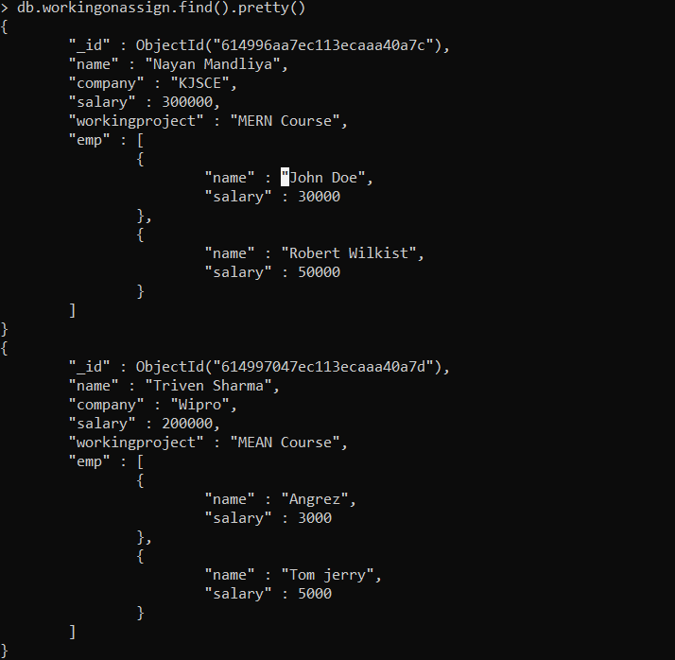

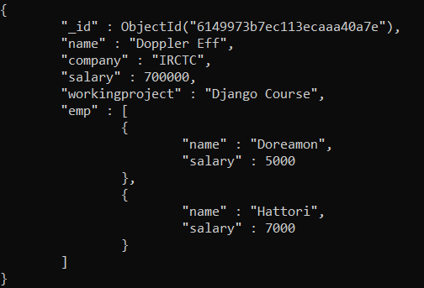

3) Finding the document having key as name and value of key as Nayan Mandliya

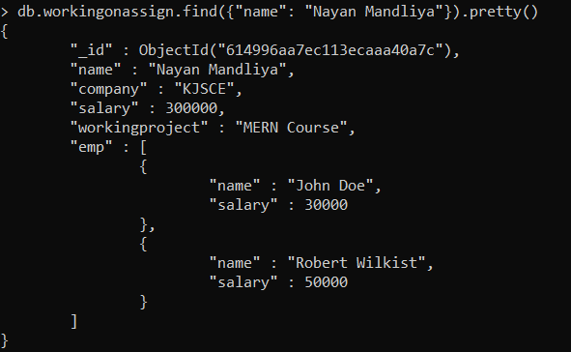

4) Finding documents with salary less than 500000.

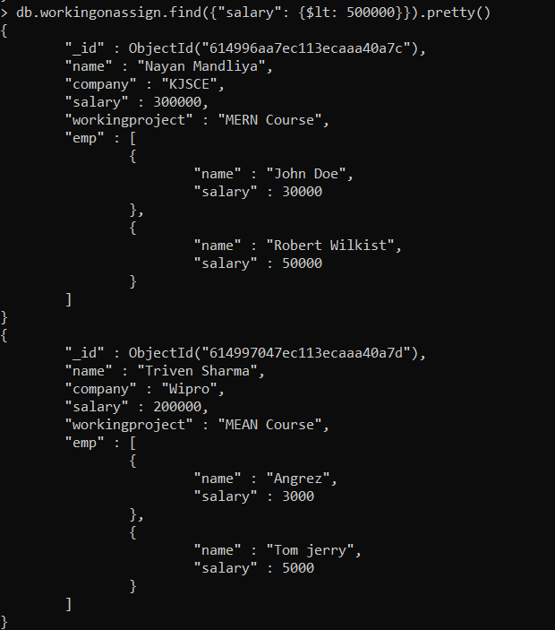

5) Finding documents with salary less than or equal to 700000

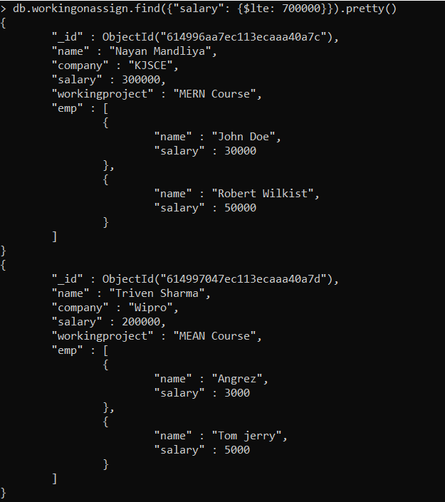

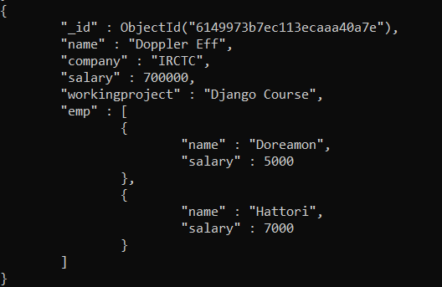

6) Finding documents with salary greater than 1000000 as there are no documents with given condition nothing will be returned. Finding documents with salary greater than or equal to 700000.

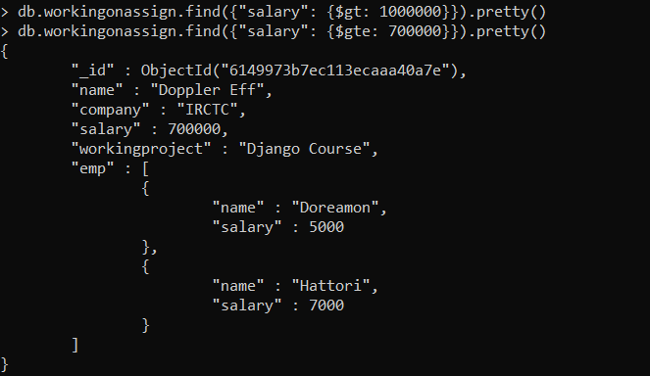

7) Documents with company not equal to IRCTC.

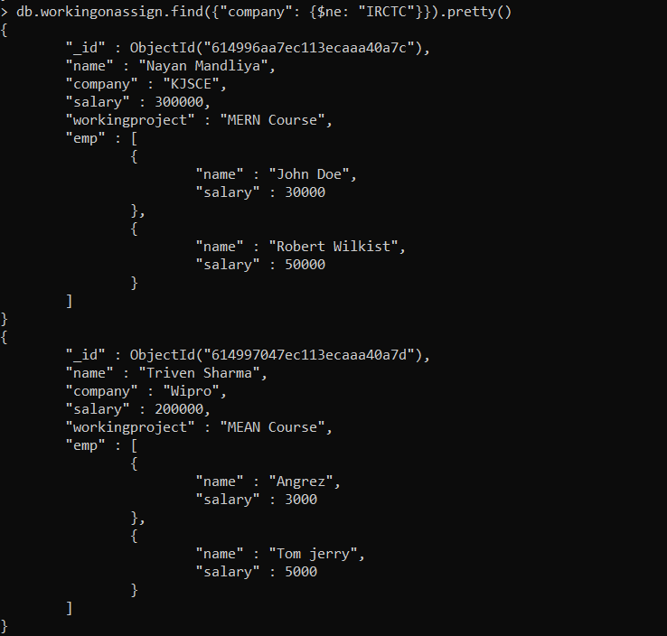

8) Retrieval of information from nested documents.

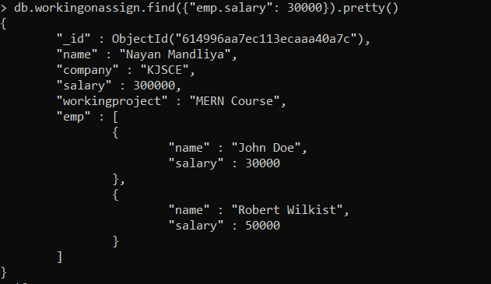

9) And:

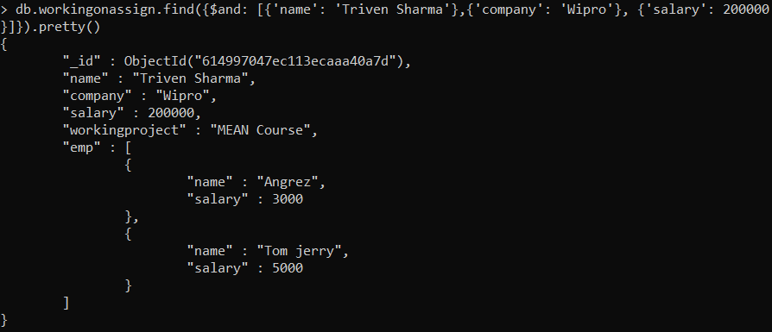

10) Or:

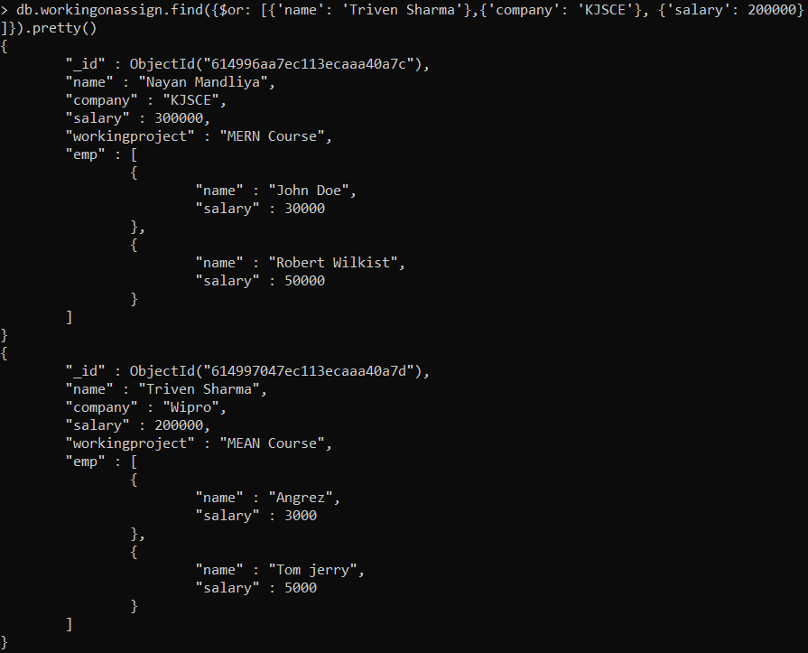

11) And and Or together:

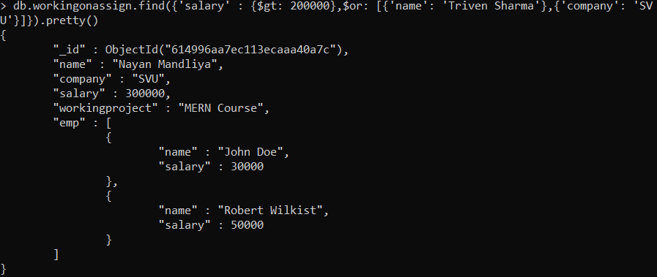

12) Update:

